Test Case: tc006_SPX_Dev5_Crear_Requisicion_Spot_Tipo_Cobro_Proyect_Urgent
Step 1 - Enter username and password and click to button Enter: Credentials Entered
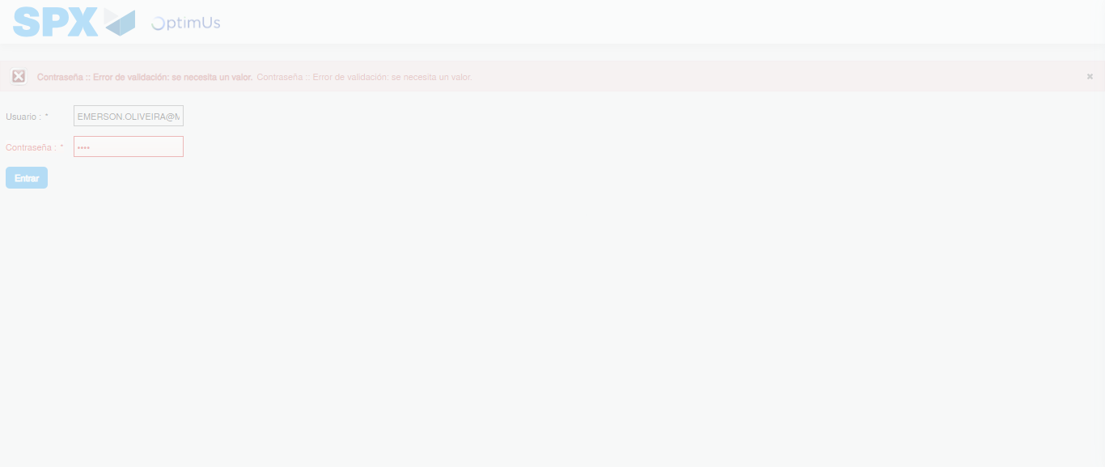Image file-name: QC_Testing-tc006_SPX_Dev5_Crear_Requisicion_Spot_Tipo_Cobro_Proyect_Urgent-1785975528302

Step 2 - Select to UEN and Access to Spot Buy Requisitions : UEN Correctly selected and Correct access
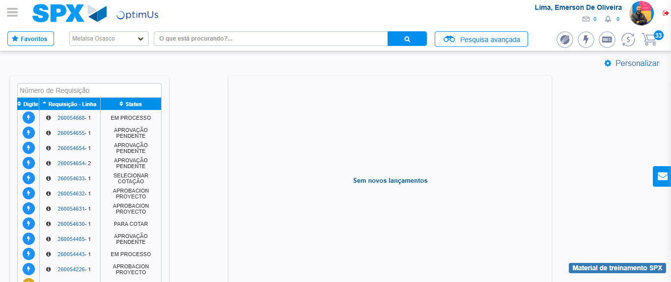Image file-name: QC_Testing-tc006_SPX_Dev5_Crear_Requisicion_Spot_Tipo_Cobro_Proyect_Urgent-1785975554012

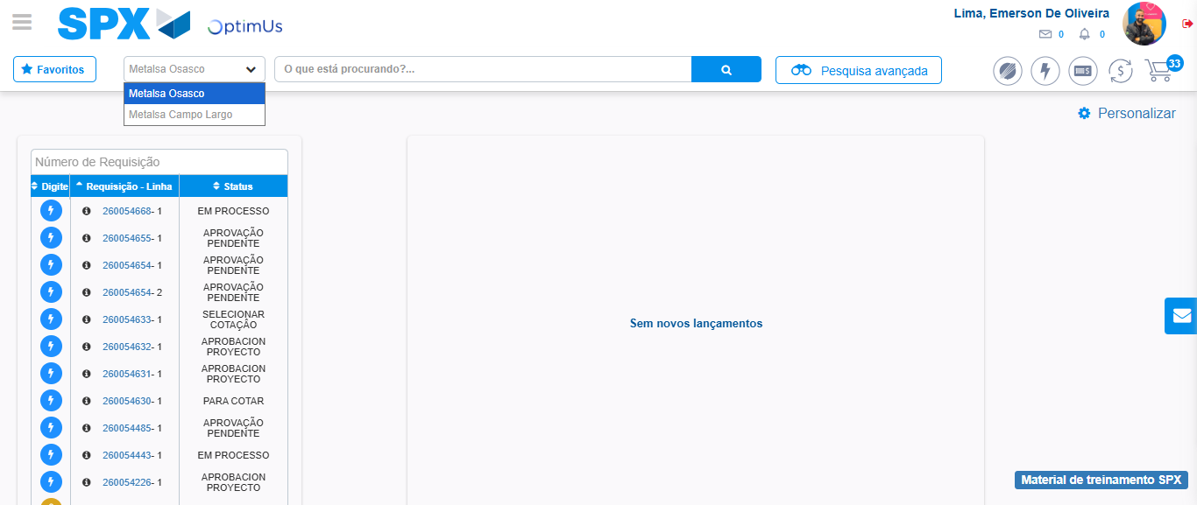Image file-name: QC_Testing-tc006_SPX_Dev5_Crear_Requisicion_Spot_Tipo_Cobro_Proyect_Urgent-1785975556730

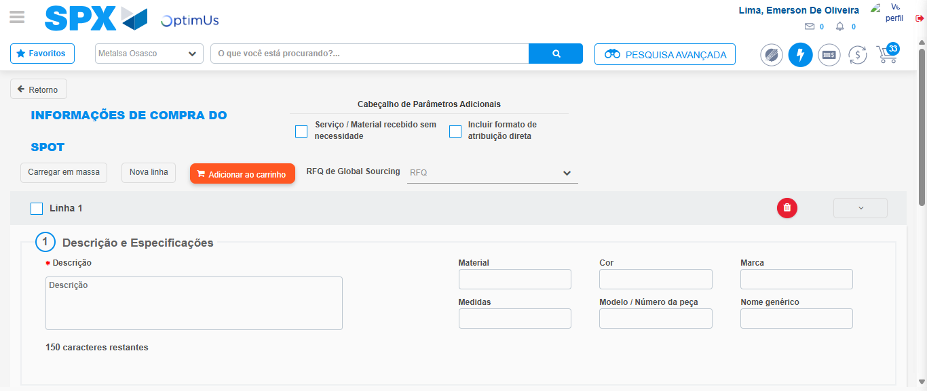Image file-name: QC_Testing-tc006_SPX_Dev5_Crear_Requisicion_Spot_Tipo_Cobro_Proyect_Urgent-1785975561576

Step 3 - Data Capture Spot Buy Requisition: Data captured correctly
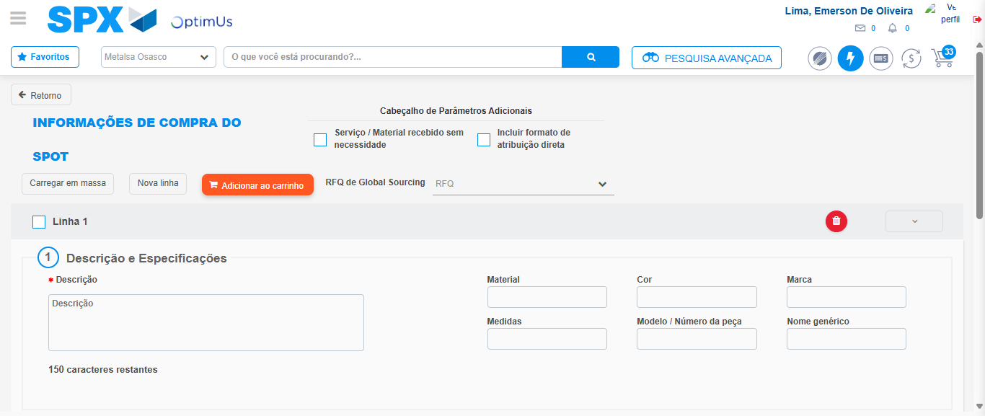Image file-name: QC_Testing-tc006_SPX_Dev5_Crear_Requisicion_Spot_Tipo_Cobro_Proyect_Urgent-1785975561891

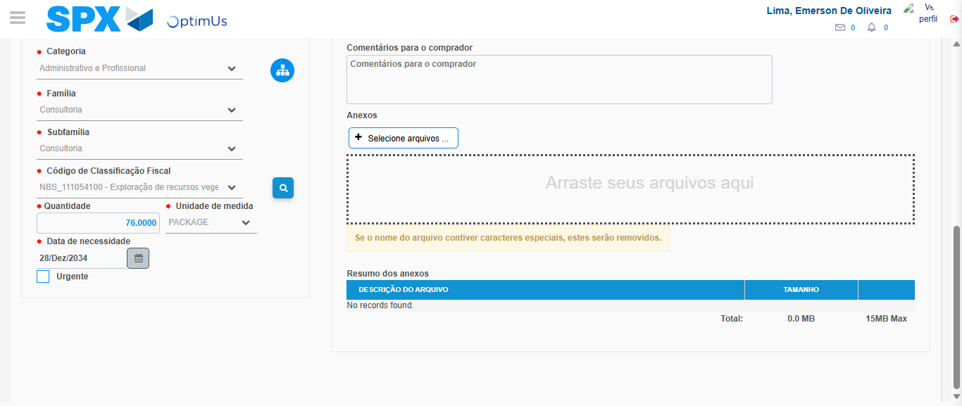Image file-name: QC_Testing-tc006_SPX_Dev5_Crear_Requisicion_Spot_Tipo_Cobro_Proyect_Urgent-1785975580126

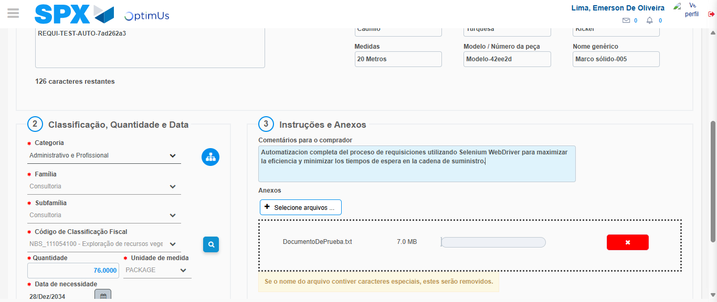Image file-name: QC_Testing-tc006_SPX_Dev5_Crear_Requisicion_Spot_Tipo_Cobro_Proyect_Urgent-1785975581153

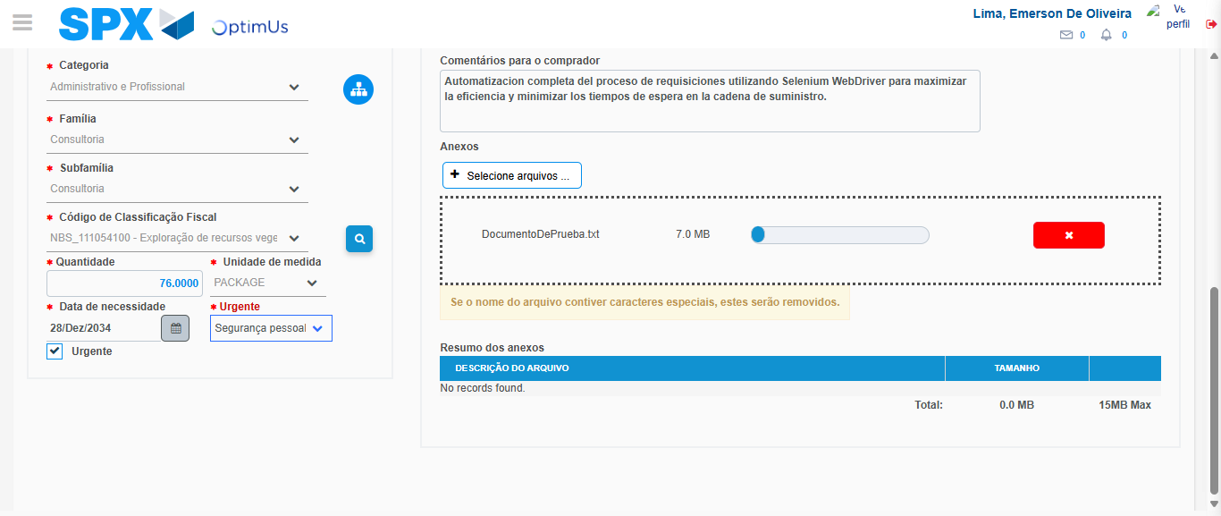Image file-name: QC_Testing-tc006_SPX_Dev5_Crear_Requisicion_Spot_Tipo_Cobro_Proyect_Urgent-1785975585163

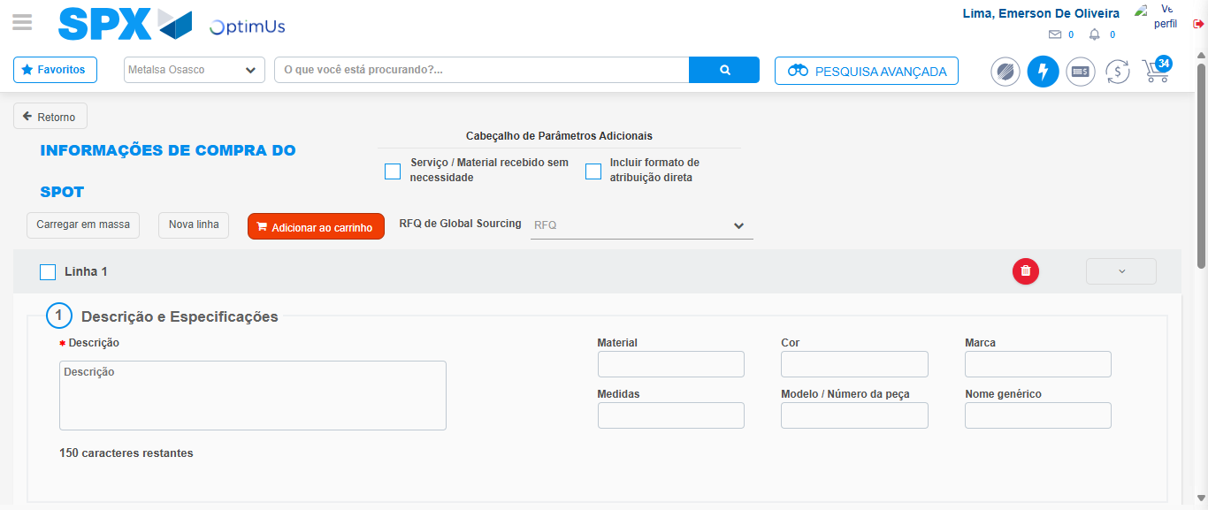Image file-name: QC_Testing-tc006_SPX_Dev5_Crear_Requisicion_Spot_Tipo_Cobro_Proyect_Urgent-1785975595499

Step 7 - Return to Main Page SPX : Return to Main Page SPX
Image file-name: QC_Testing-tc006_SPX_Dev5_Crear_Requisicion_Spot_Tipo_Cobro_Proyect_Urgent-1785975554012

Image file-name: QC_Testing-tc006_SPX_Dev5_Crear_Requisicion_Spot_Tipo_Cobro_Proyect_Urgent-1785975556730

Image file-name: QC_Testing-tc006_SPX_Dev5_Crear_Requisicion_Spot_Tipo_Cobro_Proyect_Urgent-1785975561576

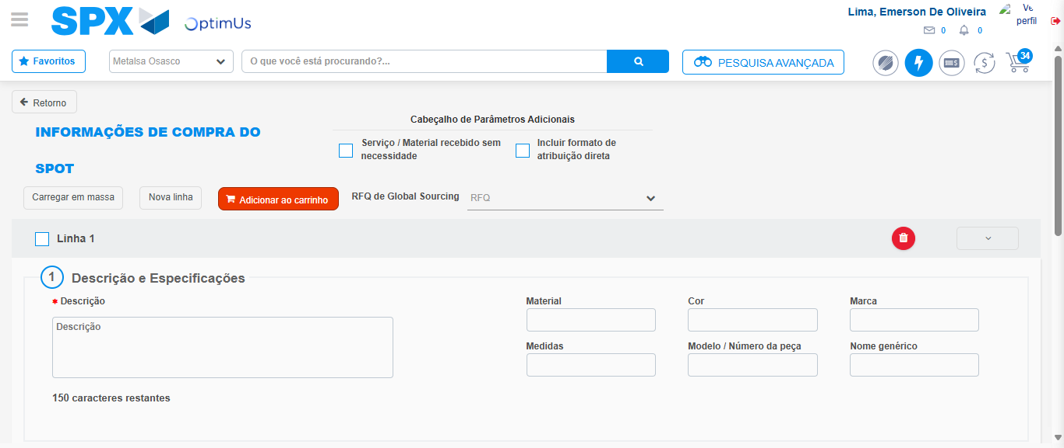Image file-name: QC_Testing-tc006_SPX_Dev5_Crear_Requisicion_Spot_Tipo_Cobro_Proyect_Urgent-1785975597769

Image file-name: QC_Testing-tc006_SPX_Dev5_Crear_Requisicion_Spot_Tipo_Cobro_Proyect_Urgent-1785975598013

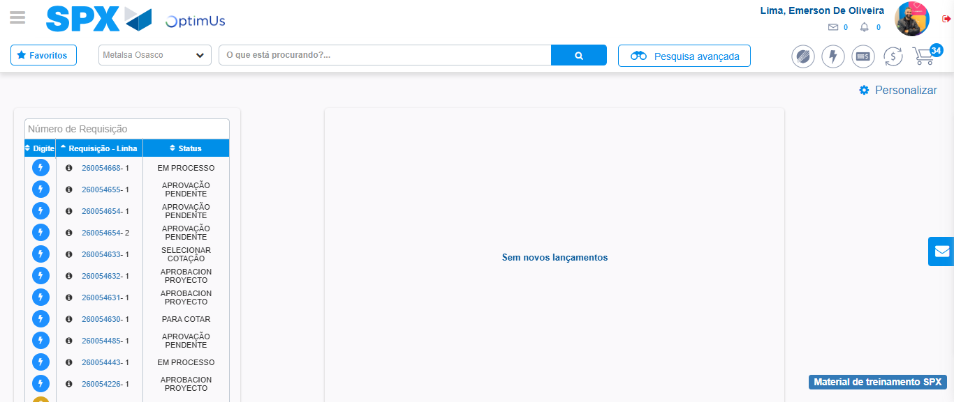Image file-name: QC_Testing-tc006_SPX_Dev5_Crear_Requisicion_Spot_Tipo_Cobro_Proyect_Urgent-1785975619091

Step 8 - Log Out : Log Out SPX
Image file-name: QC_Testing-tc006_SPX_Dev5_Crear_Requisicion_Spot_Tipo_Cobro_Proyect_Urgent-1785975619290

